PI Delegation Checklist
1. My NCBI delegation 2
2. eRA Commons delegation 3
3. ORCiD Delegation 4
4. Link eRA Commons with ORCID 5
5. MyNCBI Delegation FAQ 5
6. No Need to Complete - Miscellaneous 6

- My NCBI delegation (can sign in with eRA Commons login).
https://www.ncbi.nlm.nih.gov/
This is so I can assist you with managing your My Bibliography and SciENcv (biosketch manager). Please use my DHHA email: alana.barshney@dhha.org
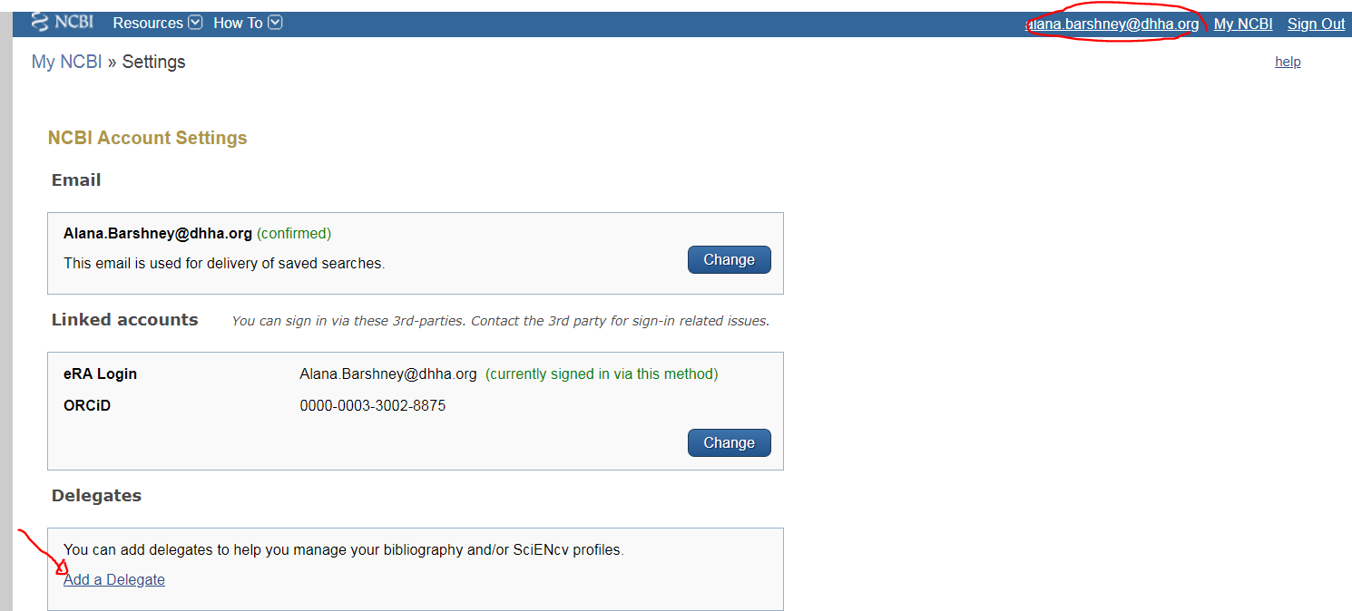
After you delegate to me, I will receive an email with a click through so that I can confirm your delegation. Once I confirm the delegation will be active with no expiration date.
I am the delegator, how can I control what my delegate has access to?
- Login to your NCBI account (https://www.ncbi.nlm.nih.gov/account/)
- Click on your username in the top-right corner of the screen to access the Account Settings page
- You can use the table in the delegates section to control what your delegates have access to.
- If you have checked the “My Bibliography” box, your delegate will have the ability to view and make changes to your My Bibliography and Other Citations collections. If you have checked the “SciENcv” box, your delegate will be able to create, view, and change your SciENcv products.
- I will need access to both in order to: 1) monitor your publications for public access policy compliance, and 2) assist with biosketch creation.

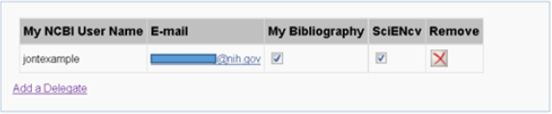

eRA Commons delegation
https://public.era.nih.gov/commons/public/login.do?TARGET=https%3A%2F%2Fpublic.era.nih.gov%2Fcommons%2FcommonsInit.do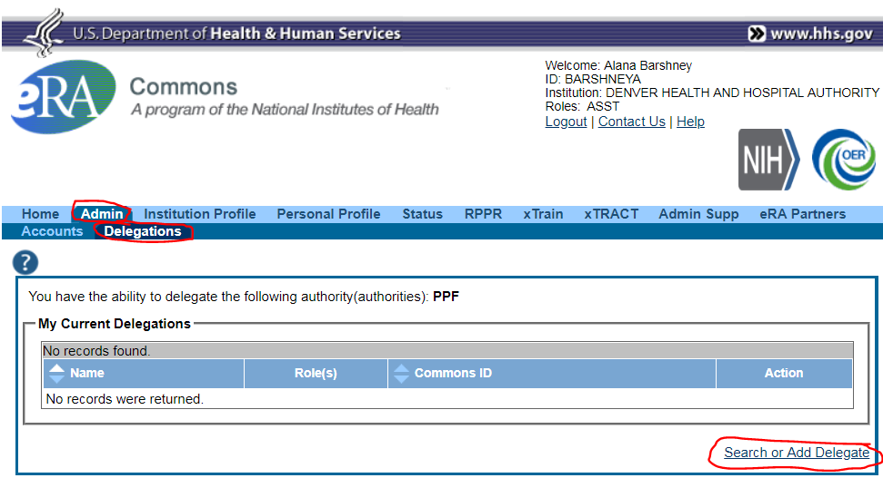
After you delegate to me, I will receive an email with a click through so that I can confirm your delegation. Once I confirm the delegation will be active with no expiration date.

ORCiD Delegation
https://orcid.org/
I can also assist you with maintaining your ORCiD profile. Go to Account Settings:
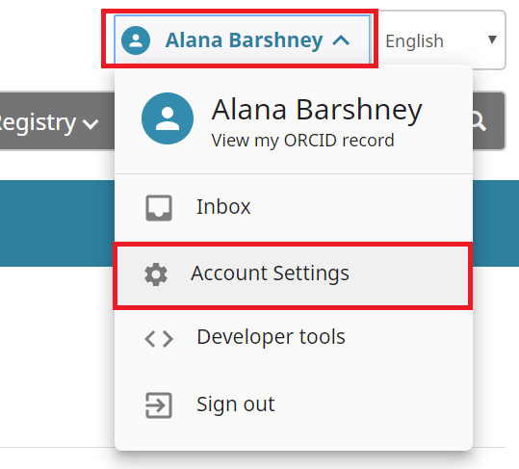
Scroll down to “trusted individuals” and enter my email address to delegate this account management to me.
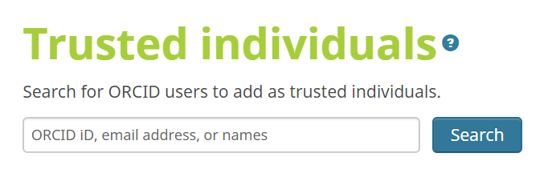

Link eRA Commons with ORCID
Go to personal profile, and there will be a prompt to link your ORCID account if you have not already. Once you enter your ORCID log in information, you will have to authorize access. This is not a delegation but a linking of your accounts.
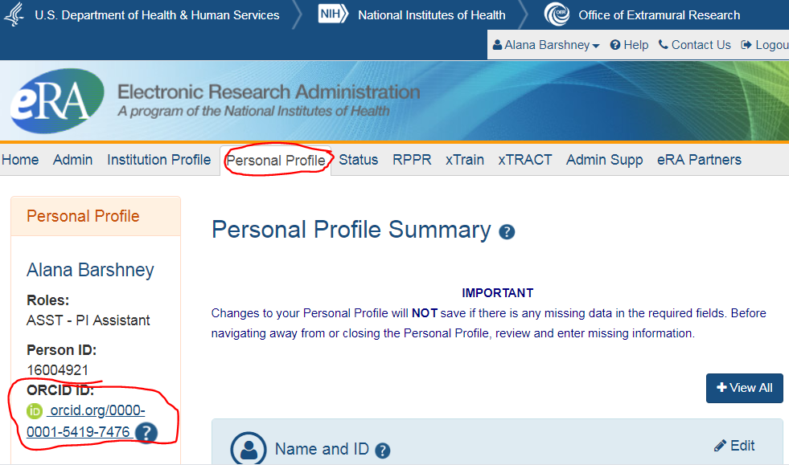

MyNCBI Delegation FAQ

My NCBI Delegates FAQ

No Need to Complete - Miscellaneous
Within SciENcv>Citations>link ORCID account (have to first create biosketch to do this, and the link is a bit hidden)
